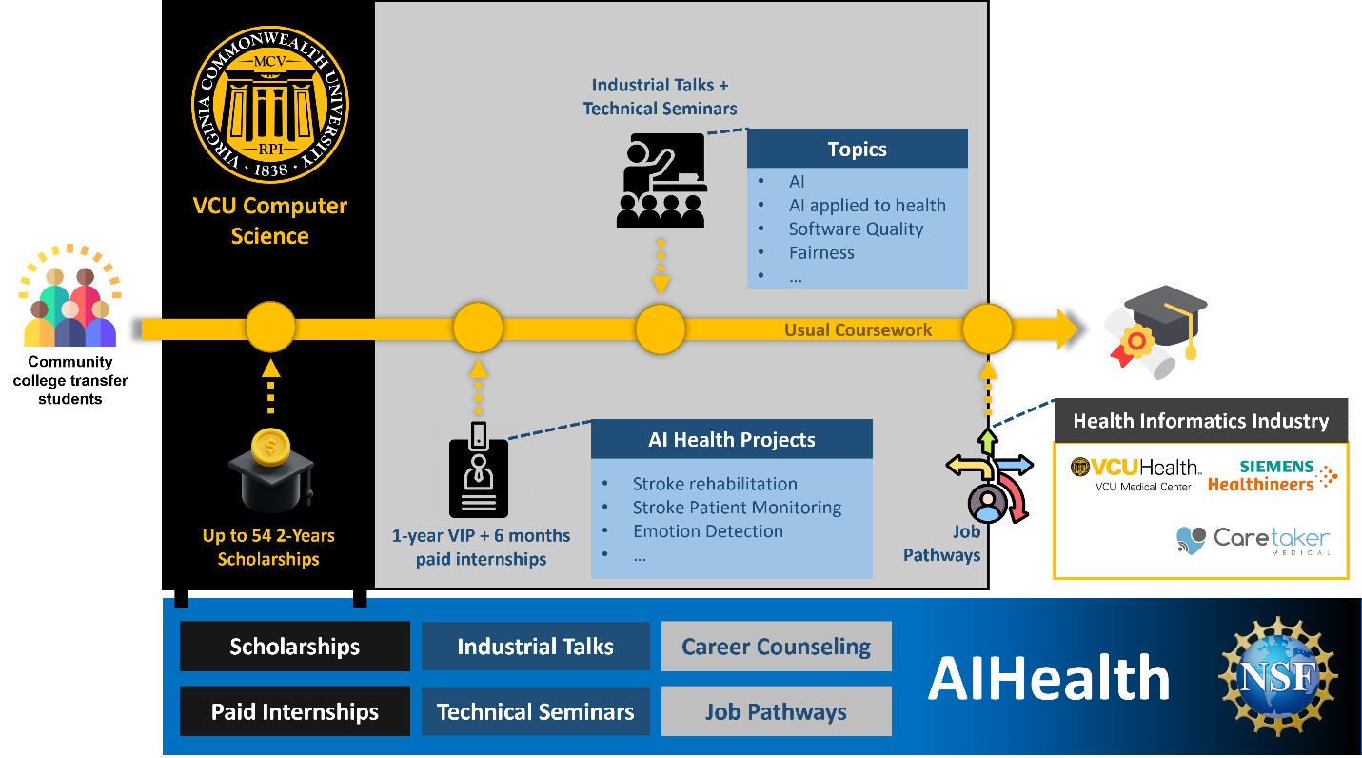

Timeline and Program Flow
- VCU Computer Science Start Point
Community college transfer students begin their journey in the Computer Science program at VCU.
- Scholarships
  - Up to 54 scholarships for 2 years are available, providing financial support to students.
  - This ensures access to resources for a diverse group of students.
- Coursework and Enrichment
  - Students engage in usual coursework, enhanced by:
    - Industrial Talks and Technical Seminars on topics such as:
      - Artificial Intelligence (AI)
      - AI Applied to Health
      - Software Quality
      - Fairness, and more.
- AI Health Projects
  - Students participate in AI Health Projects, addressing real-world challenges like:
    - Stroke Rehabilitation
    - Stroke Patient Monitoring
    - Emotion Detection
  - Projects are supported by a 1-year VIP (Vertically Integrated Projects) and an additional 6-month paid internship to provide experiential learning.
- Career and Industry Connections
  - A pathway connects students to the Health Informatics Industry, with partners including:
    - VCU Health (VCU Medical Center)
    - Caretaker Medical
    - CS PhD Program at VCU
  - These partnerships provide job pathways for graduating students.

Support Mechanisms
At the bottom, the image highlights the following support structures for students:
- Scholarships: Financial aid for qualifying students.
- Paid Internships: Hands-on industry experience.
- Industrial Talks: Exposure to industry leaders.
- Technical Seminars: Skill-building workshops.
- Career Counseling: Guidance for long-term professional development.
- Job Pathways: Direct connections to careers in AI and health-related industries.

Key Highlights
- Collaboration between academia and industry for impactful education.
- Focus on real-world AI applications in health.
- Integration of financial, educational, and career support to ensure success.
This structured pipeline ensures students gain knowledge, experience, and industry connections, preparing them for successful careers in AI for Health.

